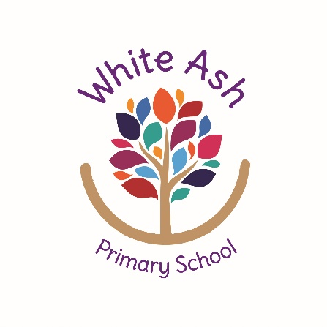
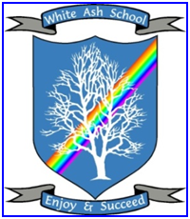
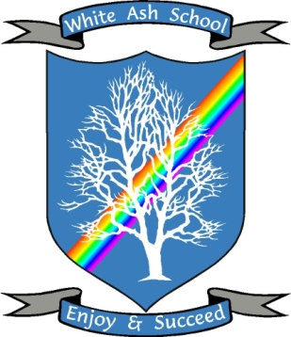
White Ash School
Early Years Foundation Stage Policy
EYFS Lead: Kirsty Bryan Date: October 2026
Introduction
White Ash School is a Generic Learning Disabilities special primary school that provides specialised learning for children with a wide range of learning difficulties and disabilities. This includes profound and multiple learning difficulties, moderate and severe learning difficulties, visual, hearing and multi-sensory impaired children and children with an Autistic Spectrum Disorder and Attention Deficit Hyperactivity Disorder.
Our School Values at White Ash are;

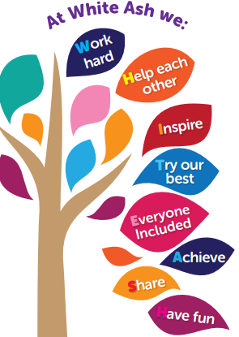

Our Intent
‘Every child deserves the best possible start in life and support to fulfil their potential. A child’s experience in the early years has a major impact on their future life chances. A secure, safe and happy childhood is important in its own right and it provides the foundation for children to make the most of their abilities and talents as they grow up.’
Early Years Foundation Stage (EYFS) Profile - Department for Children, Schools and Families 2012

Aims

To engage parents in the process of their child’s early learning experience by building and maintaining a sound ‘working’ relationship that places the child at the centre of their own learning.
- To provide a safe and caring environment, where children and staff feel secure and happy.
- To allow children to reach their full potential through a stimulating and challenging curriculum.
- To provide equal opportunities for all pupils to participate in all activities regardless of their race, sex, disability, socio-economic background, sexual orientation, gender re-assignment, religion and beliefs.
- To celebrate the achievements of all, no matter how small.
- To provide fair, consistent and clear boundaries.
- To promote and foster the positive effects of being healthy and active.

Overarching Principles

Unique child – Every child is a unique child, who is constantly learning and can be resilient, capable and self-assured.

Positive relationships – Children learn to be strong and independent through positive relationships.

Enabling environments - Children learn and develop well in enabling environments with teaching and support from adults, who respond to their individual interests and needs and help them to build their learning over time. Children benefit from a strong partnership between practitioners and parents and/or carers.

Learning and development - Importance of learning and development. Children develop and learn at different rates.

The three characteristics of effective teaching and learning are:

Playing and exploring - children investigate and experience things, and ‘have a go’.

Active learning - children concentrate and keep on trying if they encounter difficulties and enjoy achievements.

Creating and Thinking Critically - children have and develop their own ideas, make links between ideas, and develop strategies for doing things.

Safeguarding and welfare

Children learn best when they are healthy, safe and secure, when their individual needs are met, and when they have positive relationships with the adults caring for them. We are dedicated to creating a high-quality setting which is welcoming, safe and stimulating, and where children are able to enjoy learning and grow in confidence.

Please see our safeguarding policy for more information.

Behaviour

At White Ash school we use Team-Teach as our holistic approach to manage behaviour. We are dedicated to providing a consistent approach to behaviour which starts in the early years and focuses on encouraging and celebrating positive behaviour.

Please see our behaviour policy for more information.

Key Person

Each child is allocated a key person. Is it their responsibility to ensure –

- Their key children receive care tailored to meet their individual needs.
- Each child settles well and becomes familiar with their new environment.
- A positive, trusting and caring relationship is formed.
- They build a strong working partnership with families.

Medicine

At White Ash we strive to promote good health. Families are encouraged to send a toothbrush and toothpaste to school for their children. Teeth are brushed after the lunch time meal. Daily medication, prescribed by a doctor, is administered by fully trained staff. All other medication given in school must be prescribed by a doctor and the necessary forms signed and completed by parents. Parents are also encouraged to send healthy options in their child’s packed lunch.

Food and drink

White Ash is supported by The Magic Breakfast. Each morning, children are provided with healthy, balanced and nutritious breakfast/snack options.

School dinners are provided daily by our school cook. All children in EYFS are entitled to a free school meal and receive this even if they have a packed lunch. Children are supported at mealtimes to explore the food on offer using Fun With Food techniques.

Fresh drinking water is available to children at all times.

Accident or injury

At White Ash we are dedicated to supporting our children to take safe risks and ensure our environment is as safe as necessary. First aid kits are carried and used both inside and outside to limit the time spent dealing with mirror injuries so more time is spent playing and learning.

Parents are informed of any injuries sustained in school by telephone or face to face and what first aid was given if necessary. All injuries and accident are recorded on CPOMS.

Implementation

Teaching and Learning

Early Years Foundation Stage Curriculum

There are seven areas of learning and development in the EYFS curriculum. All areas of learning and development are important and inter-connected. Three areas are particularly crucial for igniting children’s curiosity and enthusiasm for learning, and for building their capacity to learn, form relationships and thrive. These three areas, the prime areas, are:

Communication and Language

Physical Development

Personal, Social and Emotional Development

There are also four specific areas, through which the three prime areas are strengthened and applied. The specific areas are:

Literacy

Mathematics

Understanding the World

Expressive Arts and Design

As well as the seven areas of learning, consideration must be given to the different ways that children learn, and these must be reflected in EYFS practice.

Pathways

Our Early Years children follow the EYFS Framework or the informal curriculum.

Individual Learning Plans for pupils on the EYFS Framework | Individual Learning Plans for pupils on the Sensory/Informal Curriculum
Communication x 1 | Communication x 2
Personal, Social and Emotional Development x 1 | Conceptual and Cognitive x 2
Physical Development x 2  PE  Self-help | Personal and Social x 2
Literacy x 2  Word reading  Writing | Tactile and Motor x 1
Mathematics x 1 | Physical and Mobility (Move/Rebound Therapy/Hydrotherapy)

Understanding the World x 1

Expressive Arts and Design x 1

Interventions (Fun with Food, Jabadao, Listen and Move)

Teaching, planning and pedagogy.

The EYFS is a separate unit away from the main building of the school. It comprises of three learning areas, Duckling Class, Gosling Class and the outdoor area. Each room is organised and suitably resourced so that children can engage in purposeful, challenging activities with or without the presence of an adult.
The school day is structured but takes into account all children’s individual needs, therefore, times/duration of planned experiences/activities are flexible and meet the needs outlined in each Childs’ Education Heath Care Plan (EHCP).
Each child has a personalised timetable which incorporates the Early Years Foundation Stage Curriculum, alongside the children’s individual therapy and personal care.
Children experience one to one individual attention/intervention and small group circle time activities related to different topics each term. They have the opportunity for outdoor learning throughout the day in our outdoor area, on educational visits and in the local community. Also, our children have time to explore and learn independently through a variety of play sessions and planned activities.
In the EYFS, our planning is topic based. We follow a three-year cycle based on nine different topic ‘big questions’ which incorporate all areas of the EYFS curriculum. Our short-term planning includes the prime and specific areas of the Early Years framework and provides access to daily continuous provision activities.
Teachers plan weekly to take into account the interests and achievements of children.
Reading
At White Ash, we recognise the importance of reading and the benefits reading has on communication and language. All of our children have a weekly reading book which they read at school and at home. Children are supported by adults to read each day, this may be their reading book, our class topic book or one of our core texts. Staff work hard to foster an early love of reading with all of our children. Reading is made special, fun and interactive through one on one time, sensory stories and cross curricular links.
Leadership and management
It is the Early Years Lead responsibility to -
- Keep up to date and well informed of any changes.
- Attend regular training and feedback to staff.
- Monitor and continually improve teaching and learning.
- Oversee the performance management of most staff.
- Complete subject leader days and dedicated leadership time.
Resources
The EYFS has a wide variety of early learning materials and equipment to meet the diverse needs of all pupils. There is also an outdoor area, which is equipped to promote continuous provision outside the classroom.
There is access to a wide range of equipment and facilities throughout the school e.g. Lightroom, Rebound Therapy, outside play area, woodlands and a Hydrotherapy pool (situated at Holly Grove).
The school minibus is available on a termly basis for educational visits to support topics and to enhance the curriculum.
Equipment is regularly reviewed and new resources are requested through the School Improvement Plan.
Supporting families
White Ash is dedicated to supporting families. We recognise that sound working relationships are formed in the Early Years and are needed for our children to grown and thrive. We place a large emphasis on this. Families are invited into school throughout the year to review and celebrate progress, participate in fun family activities and learn more about what we do at school. These events include; open evenings, starting school and six monthy reviews, weekly assemblies, coffee mornings, celebration days (Eid, Diwali), Christmas production, Christmas and Summer Fair, sport events (Special Olympics and Sport Day), Stay and play/PEEP sessions, PECS picnics, parent workshops and parent evenings.
Each day, class staff send an update to parents on Class Dojo (or face to face). Updates are centred around the learning that has taken place to ensure high quality learning can continue at home.
Impact

Assessment/Observations and Recording

On entry to the EYFS, two baseline assessments are completed on each child. The first, is the statutory Reception Baseline Assessment (RBA), an activity based assessment of pupils’ starting points in language, communication and literacy and mathematics. The second, using our EYFS Progression Document (devised from Development Matters, Birth to 5 Matters and the Lancashire SEND Toolkit ATTS) or, for our children with Profound and Multiple Learning Difficulties (PMLD), the White Ash Sensory Curriculum.
All children in the EYFS have an Individual Learning Plan (ILP) comprised of our initial Autumn baseline assessments and individual EHCP targets. ILP progress is assessed termly (Spring and Summer), and these assessments form our Early Years data.
Childrens progress is tracked on a termly basis using our two progression documents, as above, on Evidence for Learning (EFL).
Range 1 | 0 - 12 months | 0-3 years
Range 2 | 12 - 18 months | 0-3 years
Range 3 | 18 - 24 months | 0-3 years
Range 4 | 24 – 36 months | 0-3 years
Range 5 | 36 - 42+ months | 3-4 years

EYFS pupils transitioning to KS1 (Year 1) will be baselined on the White Ash Progression Document at the end of EYFS (Summer Term). Class Teachers set new ILP’s for each child to use in their new class. These targets are reviewed after the summer holidays to ensure they are still appropriate.
The Early Years profile is also completed for each pupil in the Summer Term.
As part of our daily practice, we observe and assess children’s learning to help make future plans and provide for children effectively. We record observations in a variety of ways, namely using the ‘Evidence for Learning’ app and the Engagement Model. All other observations are recorded in children’s individual Learning Journals along with annotated pieces of work, photographs and written observations. We also use a floor book to celebrate the teaching and learning which takes place in EYFS. Our pupils love to look back at the amazing work they have done and recap on events and learning with adults.
Monitoring and Evaluation
The EYFS Lead and EYFS teacher will monitor the progress and learning of children through observations, written work and oral work using Evidence for Learning. Monitoring of pupils’ progress will take place at the end of each of term. Pupil Progress evaluations will inform data analysis for the EYFS and impact on future teaching and learning. Termly progress meetings will then be arranged with SLT and interventions will be put in place for individual pupils as appropriate.
Reporting
- Children’s Individual Learning Plans are assessed and reported on to parents on a termly basis.
- Starting school reviews are carried out in the first term.
- Six monthly reviews are carried out with parents and other professionals.
- An EYFS open evening in the first half term.
- One parents’ evening at the end of each school year.
- All families are connected to Class Dojo where messages and information can be communicated daily.

Enhanced curriculum and cultural capital throughout the EYFS curriculum
- Learning Outside the Classroom – providing pupils with a wide range of outdoor activities both around the setting and within the local community, experiences and Culture Capital including educational visits.
- Brave Church Playgroup - developing play, communication and social experiences in a playgroup setting. Participating and engaging in a range of activities.
- Library - developing communication and listening skills for ASD/MLD pupils.
- Attention Autism/Intensive Interaction – to support pupils to develop early communication and interaction skills.
- Sensory Processing/Deep Pressure - to provide ASD pupils with necessary sensory input required for learning.
- Hydrotherapy/Rebound Therapy - maintain the health and mobility of our more complex children which take place on a weekly basis. Our ASD pupils also attend ASD Rebound weekly.
- Fun with Food – support children with an aversion to oral feeding to explore food in a safe, non-threatening environment. To extend restricted diets.
- Visitors and guest speakers – to provide opportunities for children to meet a wide range of people from the community linking to the learning focus.
- TAC PAC – to support the physical development of children and increased body and sensory awareness.
- MOVE – (Movement Opportunities via Education) to maintain and develop physical skills of children.
- Mobility – to develop physical mobility skills for children.
- Lightroom – to support children’s sensory, communication and ICT skills.
Transition into EYFS
Transitions into school are carefully planned to ensure we meet the needs of each individual child. During the Summer Term, a home or nursery visit, is completed by one of our Early Years teachers. Families are then invited in for an Induction Meeting with a member of SLT and the school nurse if necessary. During the meetings, a starting school information sheet is completed alongside a feeding and communication profile. In September, children transition into their new setting over our two transition weeks. Each child is given six days to attend school for their first two weeks to ensure a smooth and happy transition takes place.
Review date: October 2028

Signed _________________________ Date ___________________

